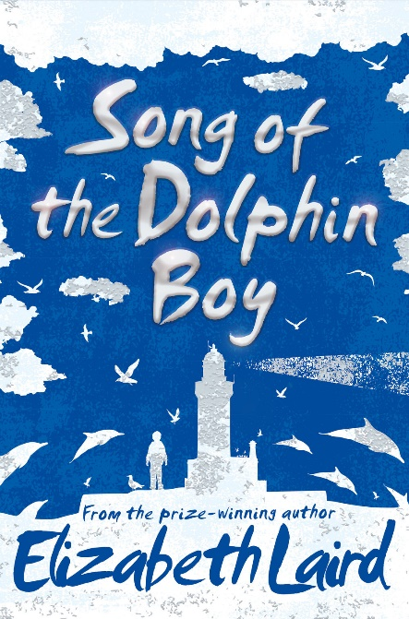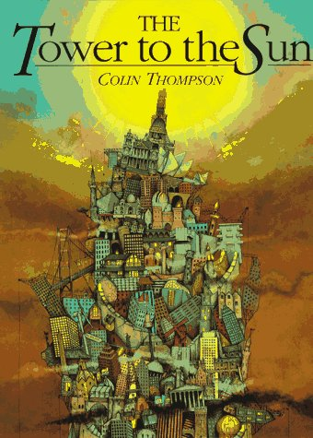[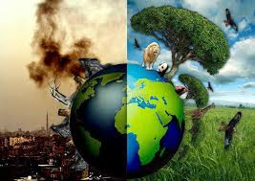](https://www.google.co.uk/imgres?imgurl=http://4.bp.blogspot.com/-FyqwJgIRY3I/UXDCMeAB1sI/AAAAAAAAABI/J-i13c7L0d4/s1600/Earth%2Bis%2Bdying.jpg&imgrefurl=http://pixgood.com/dying-earth.html&docid=nFMKSCG_1c5jaM&tbnid=50xNC1hEC__4_M:&w=600&h=424&ei=T8DYVJStKsHtUoeogqgC&ved=0CAIQxiAwAA&iact=c)

**Collect:**

On this learning journey, we will be reading a poem by M F Cowan 2009, called ‘The Only One We’ve Got’, The Tower to the Sun’ by Colin Thompson and ‘Song of the Dolphin Boy’ by Elizabeth Laird.

We will learn about the key features of the different text types and collect lots of inspirational vocabulary.

**Connect:**

We will look at the language and structural features of particular poems and work on improving our grammatical skills in fictional writing.

**Create:**

We will create our own poem based on our beautiful planet and also write a short story to inspire people to reduce, reuse and recycle to protect Earth.

**Key Vocabulary:**

environment

protect

reduce

reuse

recycle

planet

Earth

damage

climate

global warming

eco-friendly

future

**My Collected Vocabulary:**

Spring Term 1 – Why should we respect our planet?