|  |  |  |
| --- | --- | --- |
| **Item** | **cm and mm** | **mm** |
|  |  |  |
|  |  |  |
|  |  |  |
|  |  |  |
|  |  |  |
|  |  |  |
|  |  |  |
|  |  |  |
|  |  |  |
|  |  |  |

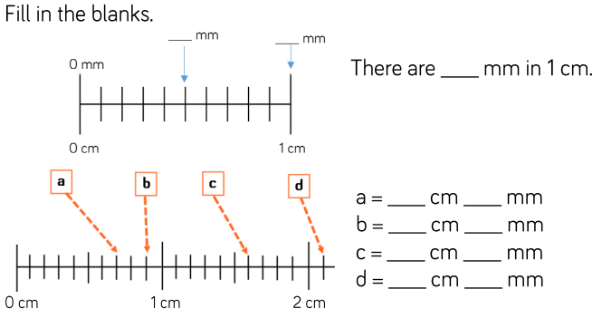

**Measure items in your house. Record the length in cm + mm and mm only.**



