Year 4 Spring 1 W/C 17.01.22 Miss Stockmann’s group
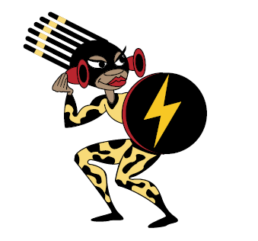
Nam___________________ (Home / School) Remember to ... Look, say, cover, write and then check.

 | Day 1 | Day 2 | Day 3 | Day 4
stares
stairs
through
threw
affect
effect
check
cheque

Year 4 Spring 1 W/C 17.01.21 Mrs Green’s group
Name ___________________ (Home / School) Remember to ... Look, say, cover, write and then check!

 | Day 1 | Day 2 | Day 3 | Day 4
stares
stairs
through
threw
earth
February
fruit
often

