Year 4 Spring 1 W/C 24.01.22 Miss Stockmann’s group
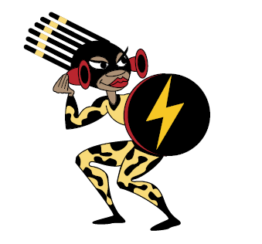
Name ___________________ (Home / School) Remember to ... Look, say, cover, write and then check!

 | Day 1 | Day 2 | Day 3 | Day 4

information
creation
education
vibration
ventilation
radiation
location
imagination

Year 4 Spring 1 W/C 24.01.22 Mrs Green’s group
Name ___________________ (Home / School) Remember to ... Look, say, cover, write and then check!

 | Day 1 | Day 2 | Day 3 | Day 4
information
creation
education
vibration
early
heart
interest
length

