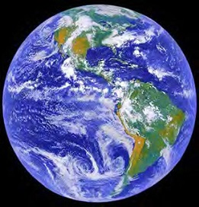
Look at our lovely Planet Earth
(Though it should be called Planet Water).
How it will look for your children
Or your Great Grandson or Daughter?
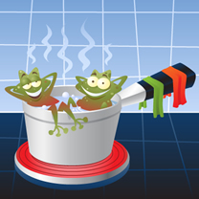
Ask yourself 'Am I bothered?'
Ask yourself 'Do I care?'
Ask yourself 'Can we make a change?'
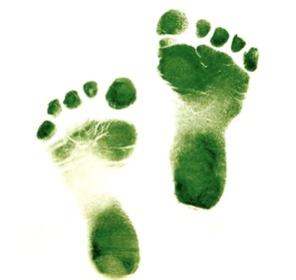
Or are we all full of hot air?

Are we prepared to make a switch
From burning coal and oil?
Or will we sit, like the frog in water
And slowly heat up and boil?

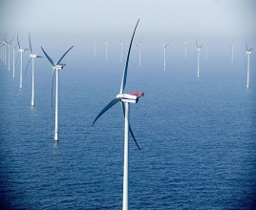
Will we step out of our vehicles
Or is this all just talk?
Will we cycle, catch a bus
Or sometimes even walk?

Are we prepared to pay a little more
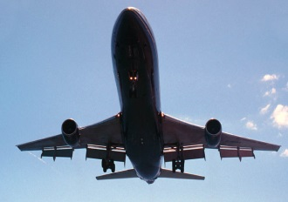
For wind, solar, wave?
Or is it your pocket, not Mother Earth
That you think of when you 'save'?

The problems are plain for all to see
And the problems are on the plane
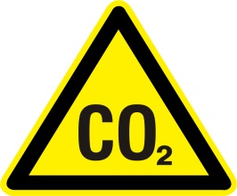
As people board Flight 304
For Portugal or Spain.
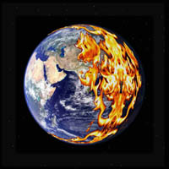
It's difficult for us to avoid
Because it must be true
That Mother Earth is being drugged
With tonnes of Co2.

Doing your bit for the planet
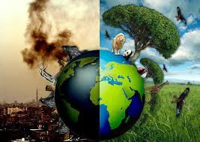
Might seem an effort (or a pain)
But ask yourself, is this a pace
That we can possibly sustain?

Has this made you worried?
Under the collar are you hot?
Let's hope so, as Mother Earth
Is the only one we've got.

